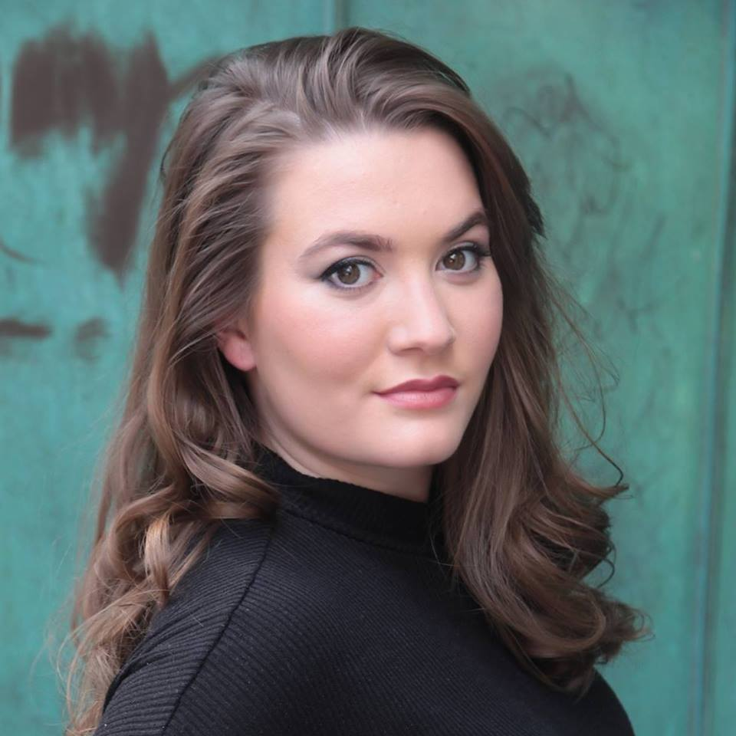

Grace Collett

London/Cornwall based

Gracecollett8@gmail.com

07817220374

Eye: Brown

Hair: Brunette

Height: 5”4

Playing Age: 15-25

Nationality: White British/ Caucasian

**Training:** National Youth Theatre of GB (2016), AMATA @ Falmouth University (2017-present)

-Awarded ‘Best Female Actor in a Leading Role’ at the Stables Theatre Annual Awards 2016/17

Other skills:

Sports: running, swimming, yoga, basic horse riding.

Accents: RP*, Newcastle, Edinburgh, Glasgow,

Other skills: Trained Barista

**Currently training at Academy of Music and Dramatic Art BA (Hons) Acting, Falmouth University.**

**Credits**  **Theatre**

**2019**

Carols Christmas Lily/Multiple Boxworks Theatre

KINO-TALE Solo Show Grace Collett for Show in a Bag (Module)

A Midsummer Nights Dream Puck Sam Hughes/ Gareth Farr for Fledge

Urinetown! The Musical Soupy Sue/Ensemble James D’Arcy/ Follies Musical Theatre Society

SPACE-TIME-EVOLUTION Ensemble/Performer Integrated Actor @ AMATA – Sally Knight/Alister O’Loughlin

**2018**

Fear and Misery of the etc Announcer/ensemble Rebecca Hulbert/Ben Symes/ Guest: Michael Grandage

Hedda Gabler Hedda Heidi Dolscher , AMATA

Grenfell – Tower of Terror Numerous Rebecca Applebee/ Devised Piece, AMATA

**2017**

How High is Up? Little Star John Berry,Printers Playhouse

**2016**

Stick Some Shoes On Woman 1 John Berry/Ellie Lane, Printers Playhouse

NYT Intake Showcase Conspiracy Theorist NYT/ Kane Husbands, NYT/Trinity Laban

Sylvia Sylvia Matt Turpin, Stables Theatre

Bula Loop Bryony Tom G Page/Tim Marriott, Brighton Fringe

**2013**

Rats Tales Mother(lead)/Chrous Niall Whitehead, Stables Youth Theatre

Alice in Wonderland Cheshire Cat Niall Whitehead/Zoe Morgan, Stables Theatre

**2012**

Crash of the Elysium Assistant Scientist Felix Barrett/Tom MacRae, Punchdrunk

Glyndebourne Singer Schools Workshops, Glyndebourne

A Christmas Carol Martha Crackett/Chorus Chris Lacey, Stables Theatre

A Midsummer Night’s Dream Bottom Niall Whitehead Stables Youth Theatre

**2011/10**

Julius Caesar Underworld Chorus Niall Whitehead , RSC Schools Festival

**Film**

2020

Her Naked Skin Florence Boorman Mark Leville AMATA Digital Showcase

“Green Eyes” Girl Ellie Ripley/Josh Collins Milo Gore Music/GLK

Foreign Lands Drunk Couple- Woman Sam Lawrence Student Film

2019

Fleabag Fleabag Caroline Jeffries Screen Acting Module

Wilderness Frances Niah Davies SoFT at Falmouth University

Two Night Stand Meghan Sam Lawrence Screen Acting Module

Sense and Sensibility Eleanor n/a Screen Acting Module

Headspace Wife (voice) Jack Latham SoFT/Equity Student Film

Hell Hotel Grace William Thompson SoFT at Falmouth University

I’m Just Unique Josie Sam Lawrence SoFT at Falmouth University

Ups and Downs Beth Will Merchant SoFT at Falmouth University

2017

Quietude Charlotte Sam Lawrence SoFT at Falmouth University

**Masterclasses and workshops**

Volcano Theatre Workshop with Catherine Bennett @ AMATA 2020

Temper Theatre Workshop with Finn Morrell @ AMATA 2019

Parkour 2 Day Training with Alister O’Loughlin @ AMATA 2019

Gecko Theatre Company Physical Theatre Workshop @ AMATA 2019

Acting for Camera Workshop with Ian Henderson at RADA 2016

Mark Gatiss Acting/Writing and Creative Industry Masterclass at Theatre Royal Haymarket 2015

Richard Bean Writers Masterclass at Theatre Royal Haymarket 2015

Youtube Production Workshop at Google HQ 2014

Angela Lansbury Acting and Industry, Theatre Royal Haymarket 2014

Richard E Grant Acting and Auditions, Theatre Royal Haymarket 2014

DreamThinkSpeak Immersive Theatre Workshop at The Roundhouse 2014

Emma Rice Artistic Director Masterclass, Theatre Royal Haymarket 2014

Glyndebourne Opera and Audition Technique 2011-2014

Hidden Agenda Movement and Text 2014

RSC Shakespeare Schools Festival Stage and Skill 2011

Janie Dee and Clive Rowe Musical Theatre 2010